**Rational Team Concert**

**Quick Start Tutorial**

**Ration**

Page Left Intentionally Blank

**Table of Content**

[1. Introduction 5](#_Toc474343818)

[2. Terminology 5](#_Toc474343819)

[3. Project Area Preparation 6](#_Toc474343820)

[3.1 Defining Timelines and Iterations 6](#_Toc474343821)

[3.2 Creating Team Areas 8](#_Toc474343822)

[3.3 Defining Roles 9](#_Toc474343823)

[3.4 Defining Releases 10](#_Toc474343824)

[3.5 Defining Categories 11](#_Toc474343825)

[3.6 Defining Work Item Types 13](#_Toc474343826)

[4. Configuration and Change Management 15](#_Toc474343827)

[4.1 Creating Work Items 15](#_Toc474343828)

[4.2 Assigning Work Items 18](#_Toc474343829)

[4.3 Updating Work Items 20](#_Toc474343830)

[4.4 Queries 21](#_Toc474343831)

[4.4.1 Using Predefined Queries 22](#_Toc474343832)

[4.4.2 Creating New Queries 23](#_Toc474343833)

[4.5 Check-out and Check-in 26](#_Toc474343834)

[4.6 Accepting Incoming Changes 28](#_Toc474343835)

[4.7 Suspending Change Sets 28](#_Toc474343836)

[4.8 Finding and Resolving Conflicts 29](#_Toc474343837)

[4.9 Viewing History of Files 30](#_Toc474343838)

Page Left Intentionally Blank

# Introduction

IBM Rational Team Concert integrates task tracking, source control, and agile planning with continuous builds and a configurable process to adapt to the way you work. This tutorial is based on version 3.0.1.1 of RTC using the scrum template and the Eclipse client.

The objective of this tutorial is to explain the basic features and helps getting started with Rational Team Concert. More information can be found in the online library of Jazz.net: https://jazz.net/library If you have comments or questions regarding this document, Jazz or Rational Requirements Team Concert, please contact catedra.ibm.fiupm@gmail.com

# Terminology

**Change set:** a repository object that collects a related group of file, folder and symbolic link modifications within a component.

**Iteration:** Projects are organized into a series of development periods called iterations. Each timeline contains a hierarchy of iterations, which can define start and end dates.

**Process:** the collection of roles, practices, rules, and guidelines that are used to organize and control the flow of work. The project process is defined in a project area and can be further customized in a team area.

**Project area:** A system representation of a software project. The project area defines the project deliverables, team structure, process and schedule.

**Report:** A set of data deliberately laid out to communicate business information.

**Roles:** Roles identify the functions of team members. Permissions for specific operations can be assigned to roles at the project level or within a team area.

**Sandbox:** An area on a file system where a developer can modify and test source code in isolation, before returning it to the source control component and sharing it with other developers.

**Snapshot:** A record of the data in the data warehouse that is used for reporting.

**Tag:** An identifier that groups related artifact.

**Team area:** The structure of the project teams is defined by a hierarchy of team areas. Use team areas to manage team membership, roles assignments and team artifacts.

**Timeline:** represents an area of activity within a project that typically has its own schedule, deliverables, teams, and process.

**Work item category:** Work item categories group work items by the various components or functional areas of your project. Each category is associated with a team area whose members are responsible for developing that component.

# Project Area Preparation

Before the start of a project it is advisable to configure the team and the process. Although these tasks can also be performed in the Eclipse client, this section uses the web client. All of the following tasks require the user to go to the Application Administration page, which can be done as follows:

1. Click on the Administration icon  and then click Manage This Project Area



## Defining Timelines and Iterations

When a project area is created it normally has a default timeline, but you can create additional timelines as well as a hierarchy of iterations for each of them.

1. On the Application Administration page of the web client, click the Timelines tab.
2. To create a timeline, click Create Timeline. Specify an identifier, which appears in the Process Configuration Source code. You can also specify a display name, which appears wherever the timeline appears in the user interface. If you do not specify a display name, the identifier is used in the user interface. You can enter start and end dates for the timeline and designate the timeline as the project timeline. Click OK. You cannot nest timelines.



1. To create an iteration, select the timeline or iteration within which to create the iteration, then click Create Iteration. Specify an identifier and, optionally, a display name. Optionally, enter start and end dates for the iteration. To enable the iteration for an iteration plan, click A release is scheduled for this iteration. Only iterations with scheduled releases are eligible for iteration plans. Click OK.



1. To set an iteration as the current iteration, select it and click the Set the Selected Iteration as Current icon.



## Creating Team Areas

Team areas can be created to assign users in particular roles for work on a timeline or a particular set of deliverables. You can create a team area within an existing project area or another team area to establish a team hierarchy.

1. On the Application Administration page of the web client, click the Overview tab.
2. In the Team Area Hierarchy pane, click Create Team.



1. In the Team Area Name field, enter a team name.
2. Optional: To change the team area timeline, in the Timeline field, select a timeline from the list.
3. Optional: To add a user to the team:

* In the Members or Administrators pane, click Add.
* In the Contributor Selection window, enter the name of a user to search for, or click Show All. Remember to use the name or last name of the user instead of the user id.
* In the Matching users pane, select a user.
* Click Add.

1. Add an optional summary and description for the team and click Save.

## Defining Roles

As part of the process definition, RTC allows defining new roles.

1. On the Application Administration page of the web client, click the Roles tab.
2. Do one of the following:

* To add a role, click the Add Role icon. Enter an identifier for the role. This ID is used in the process configuration code, and in the Role Details lists when you add members to a team. Optionally, enter a name for the role. To indicate that the role is intended to be assigned to only one team member, set the Cardinality attribute to single. To indicate that the role is intended to be assigned to multiple team members, set the Cardinality attribute to many. Optionally, enter a description of the role in the Description field.
* To remove a role, select it and click the Remove Role icon.



1. Click Save to save the changes to your project area.
2. To modify Permissions of a role, click the Permissions tab.
3. In the Configuration pane, select the timeline or iteration.
4. In the Details pane, select the roles and the permitted actions for each of them.
5. Click Save to save the changes to your project area.



## Defining Releases

Releases are the products of a team's work. The releases that you identify appear in the list associated with the Found In field on a work item.

1. On the Application Administration page of the web client, click the Releases tab.
2. Click the Add release button. Enter a name and brief description for the release. Optionally, select a creation date for the release. To limit visibility of the release to members of this project area team, click the Hide Release Visibility from All but Members of the Team checkbox. Click OK. The release appears in the Releases table. You can change the initial visibility setting of a release by clicking the checkbox in the Restrict Visibility column.



1. To adjust the order in which releases appear in the Found In field list, select a release in the table, open the Actions drop-down menu and click Move Up or Move Down.
2. When you finish defining releases, click Save to save your changes.

## Defining Categories

Categories identify the various components or functional areas of your project. Each category is associated with a team area whose members are responsible for developing that component. The categories that you define appear as the choices available in the Filed Against field in the Work Item Editor.

1. On the Application Administration page of the web client, click the Categories tab.
2. To create a category and add it to the project area:

* In the toolbar, click the Action Menu button to open the menu, then click Add Category.
* Optionally, to nest a new category within an existing category, highlight the existing category, then click the checkbox in the Actions column of that category's row. Click the Action menu button in the same cell.
* Enter a name for the category and click OK.



The new category appears in the table of categories and associated team areas. By default the new category is associated with the team area that is associated with the top-level category.

1. To associate a category with a team area:

* Optional: Select a timeline. The default timeline is <any>, meaning that the association applies to all timelines. If your process includes multiple timelines, you can specify a different association for each timeline. When a user creates a work item, it is assigned to a team area based on its category and the timeline of its Planned For iteration.
* Select the category.
* Click the corresponding cell in the Associated Project/Team Area column.
* Select the team area to associate it with, then click Associate.

If you specified different associations based on different timelines, then in the table of categories and associated team areas, the associations change when you select different timelines in the Timeline menu. The process defined for the associated team area is the process that users follow for processing the work item.

1. To remove an old category from the table, select it, then click the Archive All Selected button. To view archived categories, click Show Archived. Archived categories appear greyed out. To restore an archived category, select it and click the Unarchive Selected button.
2. You can move a category from one spot in the hierarchy to another by dragging and dropping it using the move control in the Actions column. A horizontal line indicates that it will be moved to between the category above and the category below the line when you drop it. A highlighted category indicates that it will be nested within the highlighted category when you drop it.
3. Click Save to save your work item category changes.

## Defining Work Item Types

In the scrum template, the following work item types are available:

* Adoption Item: Tracks when changes by one team must be adopted by another team
* Defect: Identifies a bug
* Retrospective: Records what went well and what did not go well in the recently completed iteration
* Story: Describes part of a use case
* Task: Describes a specific piece of work
* Impediment: Tracks things that get in the way of progress
* Epic: Used when a story is too big to complete in a single iteration (sometimes called a "sprint") or when there are too many unknowns to estimate the amount of work. An Epic can be broken down into several stories.
* Track build item: Typically created from a build result to track the fixes that are needed for a failed build

Each work item type has a state transition model that defines the states a work item can be in and the actions to move the work item throughout states. A typical state transition model provides a path from a submitted or opened state to a resolved or closed state. In states between those start and end points, team members can indicate their progress in addressing the issues described in the work item.

1. On the Application Administration page of the web client, click the Categories tab.
2. In the Choose the Work Item Type to edit section, click Add.



1. In the Add type window:

* Enter an ID for the new type. By default, the Name field is populated with the same value that you enter into the ID field. You can edit the Name field value.

1. Click Edit in the icon field and select an icon. The process templates include a set of icons that you can use. If you want an icon that is not in the list, you click Browse and navigate to a graphics file to use as the icon for the new work item type. When you are done, click OK.



1. You can add attributes in the Attributes pane.



1. State transitions of each work item type are represented as Workflows. To define the workflow for a work item type, click the Workflows section.



# Configuration and Change Management

All the activities in this section are performed using the Eclipse client.

## Creating Work Items

Create a work item to submit a defect, task, or other type of work request that the project uses.

1. In the Team Artifacts view, expand the project area node, right-click Work Items, and select New > Work Item. In the Create New Work item wizard, select the work item type, such as Defect, Enhancement, or Task. Click Finish.



1. Enter or select values for the following fields on the Overview tab:

* Summary: A brief headline that identifies the work item.
* Type: The type of work item. Commonly available types are Defect, Task, and Story. You can customize the project to include additional types.
* Filed Against: A category that identifies the functional area that the work item belongs to. For example, your project might have GUI, Build, and Documentation categories. Each category is associated with a team area; that team is responsible for responding to the work item. If you are unsure of the category, you can click the Guess Category button. The Guess Category button attempts to guess the correct category by using the text in the Summary and Description fields to search for similar work items.
* Severity: An indication of the impact of the work item, such as Minor, Normal, Major, or Critical.
* Found In: The release that the work item refers to.
* Description: A detailed description of the work item. For example, the description for a defect might include a list of steps to follow to reproduce the defect. Any descriptions that are longer than 32KB are truncated, and the entire description is added as an attachment.



1. On the Links tab, add attachments, screen captures, and subscribers, and specify related work items.



1. Click Save to save the work item.

## Assigning Work Items

Assign a work item to a specific user.

1. Click the Find Potential Duplicates icon to see if another work item has been submitted about the same issue. If a duplicate work item exists, set the state of one of the work items to Resolved and set its Resolution to Duplicate. Then, click the Links tab in one of the work items, and click Add > Add Related to find and link to the other work item.



1. The Owned By list contains all members of the team area that is associated with the work item category. Select an owner from that list or click more at the bottom of the list to search for a member of another team.
2. Set the value in the Planned For field to a planned iteration for resolving the work item, and enter a value in the Due Date field.
3. To add a comment, in the Discussion section, click Add Comment, and enter your text.



1. An approval is a request for other users to review, approve, or verify the work that is done to resolve the work item. To add an approval:

* Click the Approvals tab.
* Click New: Approval, select the type of approval, and specify the due date.
* Specify the user or users who are responsible to approve the resolution by clicking Add Approver. You might want to create different approval types for different users. For example, you might want to have a lead developer review the owner's proposed resolution, and a test engineer validate the delivered fix.



1. Click Save to save your changes.

## Updating Work Items

As you address the issues that are raised in a work item, periodically update the work item to describe its state and your work.

1. Open the work item. From the State list, select Start Working.



1. Use the work item to collaborate with team members:

* To enter a question or comment, in the Discussion section, click the Add Comment link and type your text. All subscribers of the work item receive notification of your comment when you save the work item. When you add a comment, you are added as a subscriber.
* To send an email to the submitter of the work item, next to Create By, right-click the submitter's name and select Send Mail.
* If you change the owner to a different user, add a comment that explains why you reassigned the work item.

1. Click Save to save your changes.
2. You can view the history of a work item in the History tab.



1. When you have completed the work for a work item, resolve it:

* Open the work item.
* From the State list, select Resolve.
* In the adjacent Resolution list, select an entry that describes why you resolved the work item, such as Fixed, Works for Me, or Duplicate.
* In the Discussion section, type a comment that further explains your actions.
* Optional: If you resolve a work item as a duplicate, specify the other work item in the Links section on the Links tab.
* Click Save to save your changes.

## Queries

The primary method for finding work items is to run queries against the repository. Queries retrieve work items whose attributes contain values that match the values specified in the query. For example, you might run a query that retrieves all work items whose status attribute is in an unresolved state. Jazz provides a set of predefined queries, and you can create additional queries. You can also retrieve a specific work item by entering its ID, and you can search for an item by entering a text string. You can also find work items from the plan.

### Using Predefined Queries

1. Within the Team Artifacts view of the Work Items perspective, expand the project area. Click Work Items >Shared Queries > Predefined.



1. Double-click a query to run it. The results are displayed in the Work Items view.



1. To see the details of a work item, double-click it in the Work Items view. The work item opens in the work items editor.

### Creating New Queries

1. In the Team Artifacts view of the Work Items perspective, expand the project area. Right-click Work Items and select New > Query.



1. In the query editor, enter a name for the query in the Name field. Depending on the type of query you want to create, click one of the following links:

* Start from scratch: This query is based on a unique set of conditions. To create this type of query, after you click Start from scratch, follow these steps:
* Click the Add Conditions icon.
* In the Add Conditions window, select the attributes to use as query conditions, and click OK.
* For each attribute, specify the value or condition that must be met. For example, for the Due Date attribute you can use a specific date or a relative date, such as 15 days from now.
* If you want to nest conditions and groups of conditions, click the arrow icon next to the Add Condition icon and select the type of condition to add. For each group, click All must match and select AND or OR. Use AND when all of the conditions you specify must be met for the query to return a work item. Use OR when any one of the conditions must be met.



* Simple Query: This query uses the Status, Category, Owner, and optional text conditions. To create this type of query, after you click Simple Query, follow these steps:
* Select one or more values for the Status, Category, and Owner attributes.
* Optionally, enter a text string. The query searches fields of the work items for matching occurrences of the text string. Queries for string-based fields, such as Summary and Description, are not case-sensitive. Add and remove conditions as necessary.



* Full Text Query: This query searches all fields of work items for a text string. To create this type of query, after you click Full Text Query, follow these steps:
* Enter the text string.
* Add and remove conditions as necessary. Queries for string-based fields, such as Summary and Description, are not case-sensitive.

1. Click the Details tab. Enter a description of the query so that other users can understand what work items the query returns without reading the Conditions tab.
2. By default, new queries are private. To share a query with members of a team, click Add Team Area and select a team. To share a query with a specific user, click Add User and select the user.
3. Click the Result Layout tab. In the Result Columns section, double-click each attribute that you want to display as a column heading in the query results grid. Scroll to the Sorting area. Double-click the attribute to use for sorting the work items in the query results grid. In the Selected sort columns table, you can set the sort direction to Ascending or Descending. The first attribute that you select is the primary sorting attribute. You can specify additional sorting attributes.
4. Click Save to save the query.
5. To run the query, click the Run icon.
6. To create a feed for this query, click the Create RSS Subscription for this Query icon. When any work items that are selected by this query change, you will receive notifications in the Team Dashboard view.

# Rational Team Concert source control

Rational Team Concert source control stores artifacts such as files and folders in the Jazz repository. You create a **Repository Workspace** to hold your private copies of the files and folders that you want to work with, and then load the contents of your repository workspace into a sandbox (a directory in your computer's file system) so that the files and folders are accessible to tools like editors, compilers, and integrated development environments. As you make changes to the contents of your sandbox and save, the changes will be accumulated in **Unresolved** component under Pending Changes view. You periodically check them in, which copies them to the repository workspace, so that the changes are backed up on the server. In the repository workspace, related changes are collected as **change sets**, which enable changes in multiple files and folders to be delivered in a single operation.

Figure 1 illustrates a simple configuration of a repository workspace and a single component. Check-in copies changes from the sandbox to the repository workspace, creating change sets. These change sets can be delivered to stream from Repository Workspace.

Load loads the sandbox with the contents of the repository workspace.

Check-in copies work from your sandbox to your repository workspace.

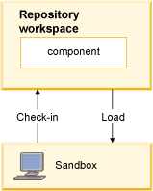

Figure 1

When you work as part of a team, your workspace and the workspaces of other team members are configured to deliver their changes to a shared repository object called a stream. [Figure 2](https://www.ibm.com/support/knowledgecenter/en/SS2L6K_6.0.1/com.ibm.team.scm.doc/topics/c_getting_started.html?view=kc" \l "c_getting_started__fig_ws-stream) shows how change sets are created in a sandbox and then checked in to a repository workspace can be shared by delivering them to a stream that all team members use. Because the stream is a flow target of all team members' repository workspaces, the change sets it contains are accessible to all team members.

Figure 2. Change sets checked in to a repository workspace can be delivered to a stream to make them available to other team members

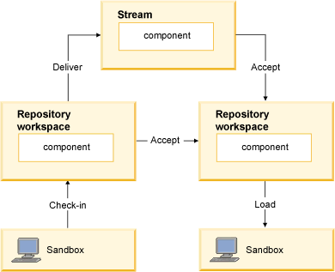

Figure 2

**Creating a Repository Workspace:**

1. Expand source control directory->New->Repository Workspace

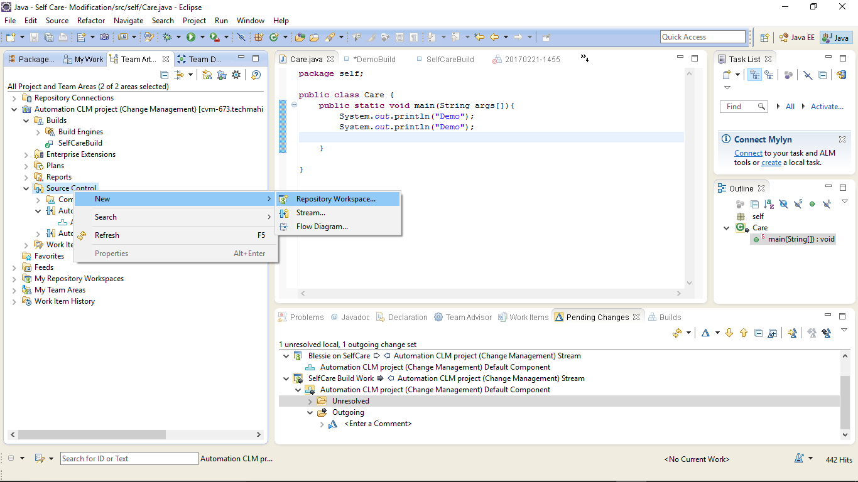

1. In the New Repository Workspace wizard, on the New Repository Workspace page, in the Repository Workspace name field, type a name and click Finish.

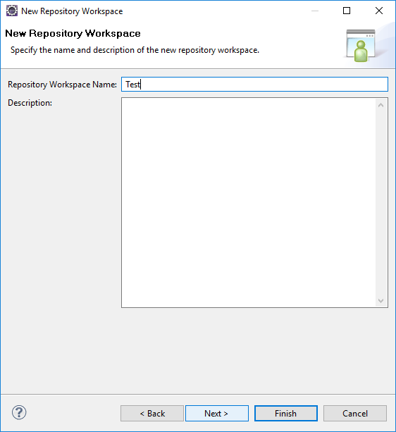

1. On the Load Repository Workspace page, ensure that Find and load Eclipse projects is selected and click Finish. This action creates and loads your new repository workspace into your sandbox. The load completes quickly, since there is no code in the stream yet.

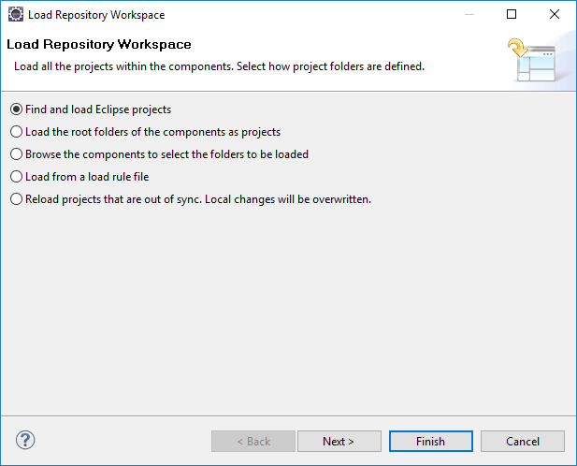

1. When a repository workspace is loaded, it displays in the Pending Changes view. If the Pending Changes view is not visible, click Window > Show View > Pending Changes.

**To check your project into Jazz Source Control:**

1. Open the Java perspective. If this is not the current perspective, click Window > Open Perspective > Java.
2. From the Package Explorer view, select a project.
3. Right-click; then click Team > Share Project.

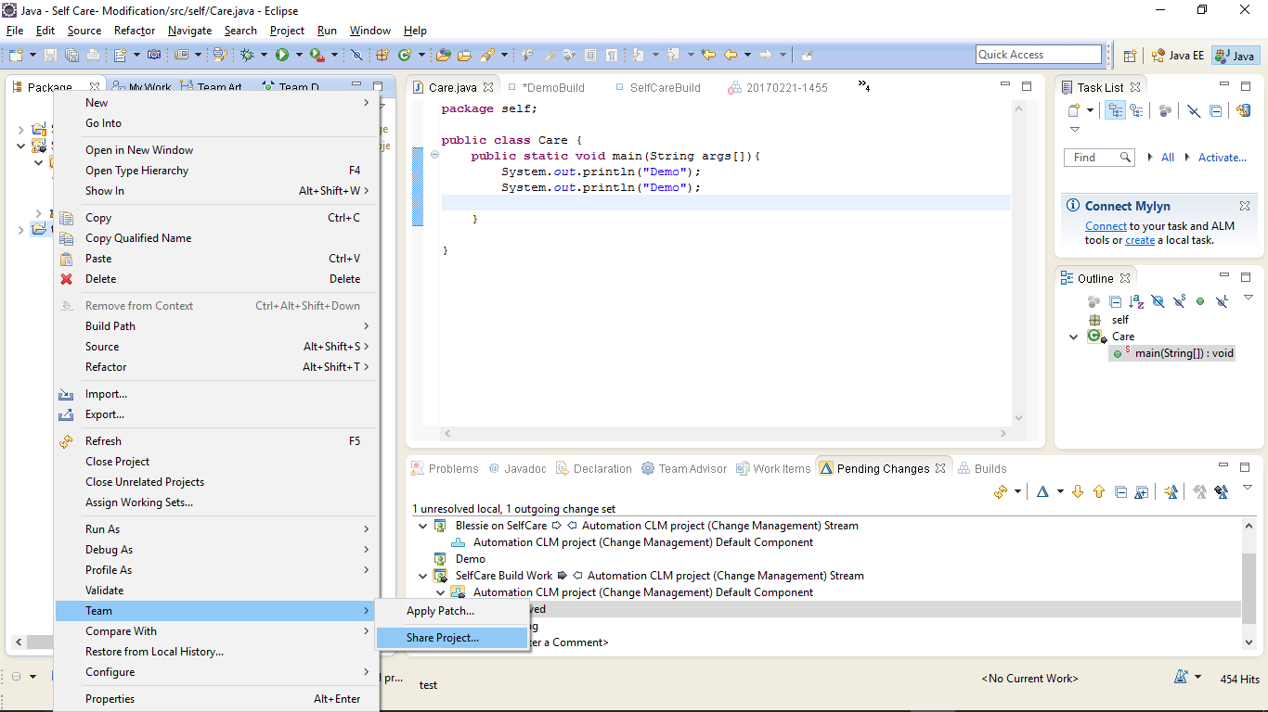

1. In the Share Project wizard, on the Share Project page, select Jazz Source Control and click Next.

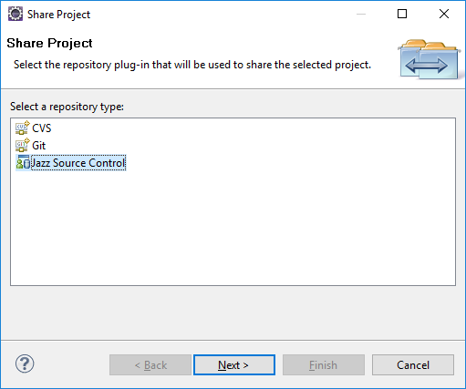

1. On the Select Component page, ensure that repository connection is selected from the drop-down list at the top of the page. Also, make sure select a component in an existing repository workspace is selected. Expand Test Repository Workspace and select the component.

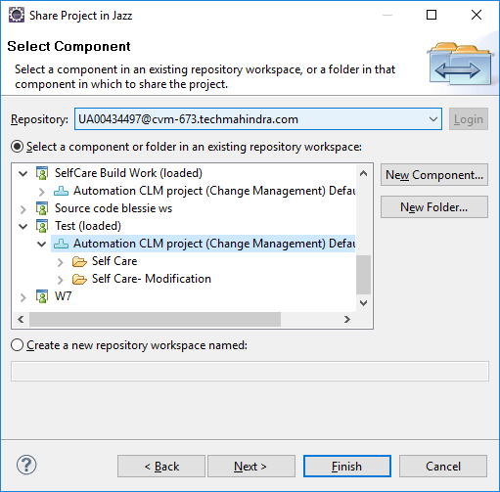

**To deliver the changes and make them available to the rest of the team:**

1. In the Pending Changes view, right-click on a change set; then click Related Artifacts > Associate Work Item.

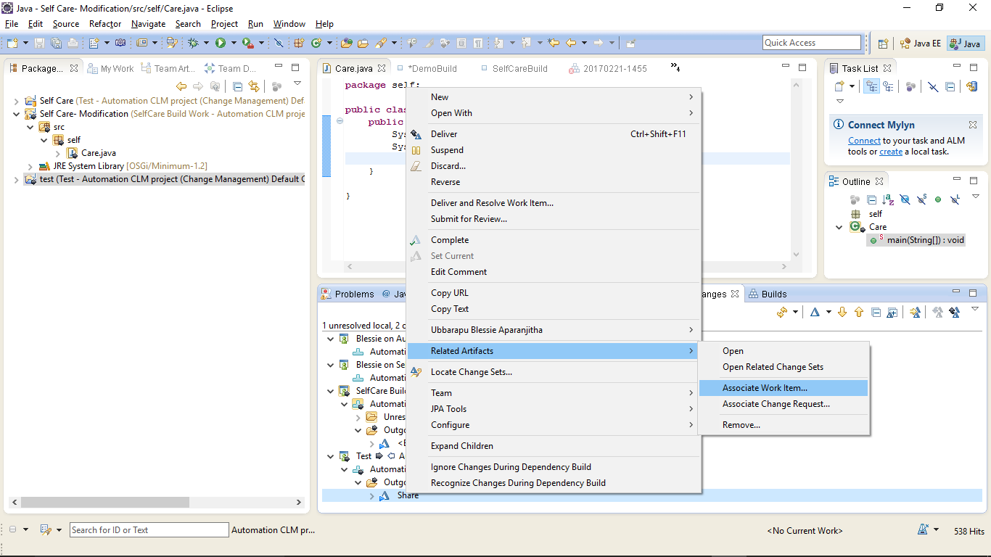

1. In the Select Work Items dialog box, select the work item and click on OK.

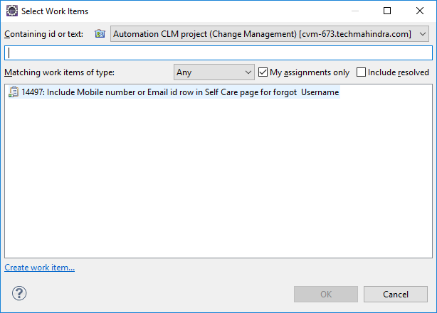

**To deliver and resolve the work item, in the Pending changes view, complete the following steps:**

1. Right-click on the change set; then click Deliver and Resolve Work Item.

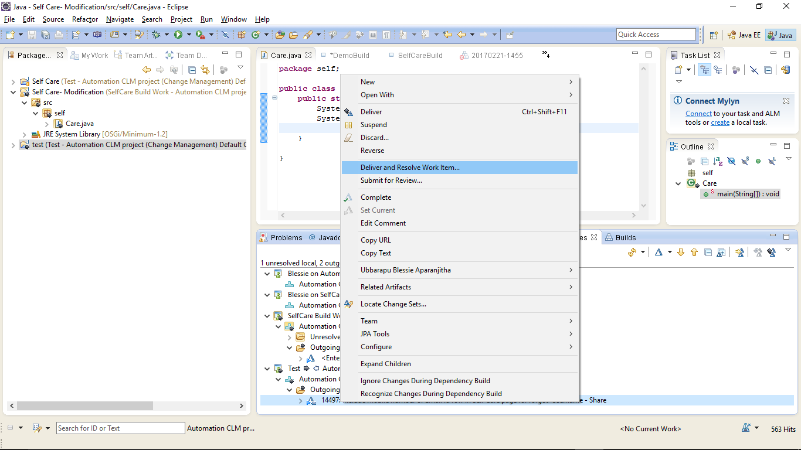

1. In the Add a comment to the work item pane, type a comment to add to the work item.

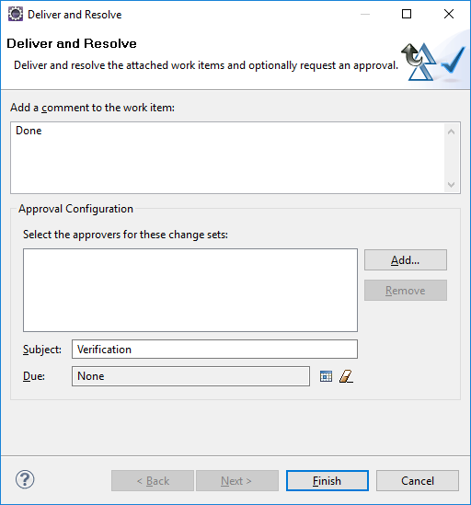

1. Click Finish.

## Check-out and Check-in

RTC does not require a check-out operation before you can modify files or folders. All files in a sandbox are normally writable. Modified files remain private to your repository workspace until you deliver them.

1. To check-in the changes, go to the Pending Changes view.
2. Verify the changes and when you are ready right-click the item and select Deliver.



1. Because a change set cannot be checked-in without being associated with a work item, an error will appear in the Team Advisor view.



1. Click Associate Work Item and select the work item to be associated to the change set.



1. Perform steps 1-2 again.

## Accepting Incoming Changes

A change set is classified as incoming when it is present in a workspace flow target but not in the workspace itself.

In the Pending Changes view, incoming change sets are visible in the Incoming folder for the component. You can accept an incoming change set to add it to your repository workspace and load it into your sandbox.

If an accepted change is causing problems in your workspace, you can discard it. This action unloads it from the sandbox, removes it from the repository workspace, and returns it to the Incoming folder, effectively undoing the accept operation that added it to your workspace.

1. To accept incoming changes, go to the Pending Changes view.
2. In the Incoming folder, verify the changes and when you are ready right-click the item and select Accept.

## Suspending Change Sets

Suspending a change set removes it from the repository workspace and unloads it from the sandbox but preserves it in the repository so that it can be restored when you want to resume work on it.

1. In the Pending Changes view, navigate to the change set that you want to suspend.
2. Right-click the change set and click Suspend.



1. The change set moves to the component's Suspended folder. New changes accumulate in a new change set, or in an existing one that you designate as current.
2. To continue working on a suspended change set, go to the Suspended folder.
3. Right-click on the suspended change set and select Resume.



## Finding and Resolving Conflicts

When Rational Team Concert source control detects that the same file exists in an outgoing change set and an incoming change set, it recognizes that a potential conflict exists and places orange icon overlays  beside the Outgoing and Incoming folders that include the conflict. A conflict is classified as a potential conflict until you accept the change set that contains it. You cannot deliver a change set that includes a potential conflict. If you accept a change set that includes a potential conflict, the potential conflict is realized, and must be resolved in your workspace.

1. In the Pending Changes view, navigate to the change set in the component's Incoming folder. When you select a file in the Incoming change set, the conflicting file in the Outgoing change set is highlighted.
2. To review the potential conflicts, right-click each file that has the potential conflict icon () beside it and click Open in Compare Editor.
3. After you review the differences, take one of the following actions:

* To accept the incoming change set that contains the potential conflict, right-click it and click Accept. The  overlays are replaced  with overlays, non-conflicting files in the change set are accepted into your workspace and the potential conflicts become actual conflicts, which you must resolve.
* To suspend the outgoing change set, right-click it and click Suspend.
* To permanently remove the change that is causing the conflict, right-click the file in the outgoing change set and click Undo.
* To discard the entire outgoing change set, right-click it and click Discard.

## Viewing History of Files

The History view of a file lists all the change sets, one per line, that include the file. You can open any of these change sets in the Change Explorer view to see more detail about individual items in the change set.

1. In the Repository Files view, right click the file and select Show History.



1. Double click the selected work item to view the details.



Page Left Intentionally Blank